Original scientific article / Izvirni znanstveni članek

TITLE
NASLOV

Name SURNAME¹, Name SURNAME², Name SURNAME³
(1) affiliation, full postal address, e-mail address (unemployed people)
(2) affiliation (e.g., University, Faculty, Department), country, e-mail address (employed people)
(3) …

ABSTRACT
Each paper must be equipped with an abstract in English and in the language of the manuscript (if not English). The abstract shall not exceed 150 words. The summary shall briefly explain the aims, methodology used, key results and major outcomes of the research. The authors are encouraged to also point out the limitations and applicability of their findings.

IZVLEČEK
Abstract in Slovenian will be provided by the editorial office.

Key words: Authors are encouraged to provide up to ten (10) keywords in Slovenian and English. Keywords are used for indexing purposes and shall support (and not duplicate) the title. Decimal classification of the manuscript is provided by the editorial office.

Ključne besede: Key words in Slovenian.

1 INTRODUCTION
1 UVOD

Acta Silvae et Ligni publishes original and review scientific papers from all areas of forestry and forest sciences, forest ecology and forest space, wood technology, nature and environmental sciences. The authors should submit articles with all attachments through the web interface along with “Permission for Publishing.” The editorial board appeals to the authors to carefully read the publication ethics chapter.
It is suggested that the authors prepare manuscripts in Times New Roman (Normal style), size 12, single spacing, in black colour. Italics shall only be used for Latin names of taxa. Tables and graphics shall be placed directly in the text at the appropriate position. Submitted manuscripts must be prepared according to the stated instructions. One manuscript should not exceed 45,000 characters (including spaces), unless a need for more text is justified in the cover letter.
Acta Silvae et Ligni publishes manuscripts in Slovenian, English or any other IUFRO official language (Spanish, German, French). Authors are responsible for translation of the abstract and summary, except for invited papers. The journal will ensure the proofreading of texts in English or Slovenian. Authors are not charged for proofreading.
The title shall be clear, concise and informative, and should sum up the essence of the presented research. Avoid abbreviations and formulae where possible.
Write names of genera and species of phytocoenology associations throughout the text in italics. For names of plants, animals and fungi, provide the authorities upon the first usage of the name.

2 METHODS
2 METODE
2.1 1st Order subchapter
2.1.1 2nd Order subchapter
Please arrange the manuscript in IMRaD chapters. All chapters and subchapters shall have an informative name, shall be organised as shown above and translated into Slovenian and English (or the language of the manuscript). The numbering should end with chapter SUMMARY.

3 RESULTS
3 REZULTATI

Prepare tables and figures in high quality/resolution, formatted to the size and shape of the journal. You are kindly requested to number tables and figures consistently and to refer to all of them in the text. The titles of the tables (Table) are written above the tables, and the titles of the images (Fig.) below the images. Mark unambiguously the position of tables and figures in the final text. Provide captions for all tables and figures, which shall be understandable as stand-alone text explaining the content.
E.g.

Preglednica 1: Opis
Table 1: Description

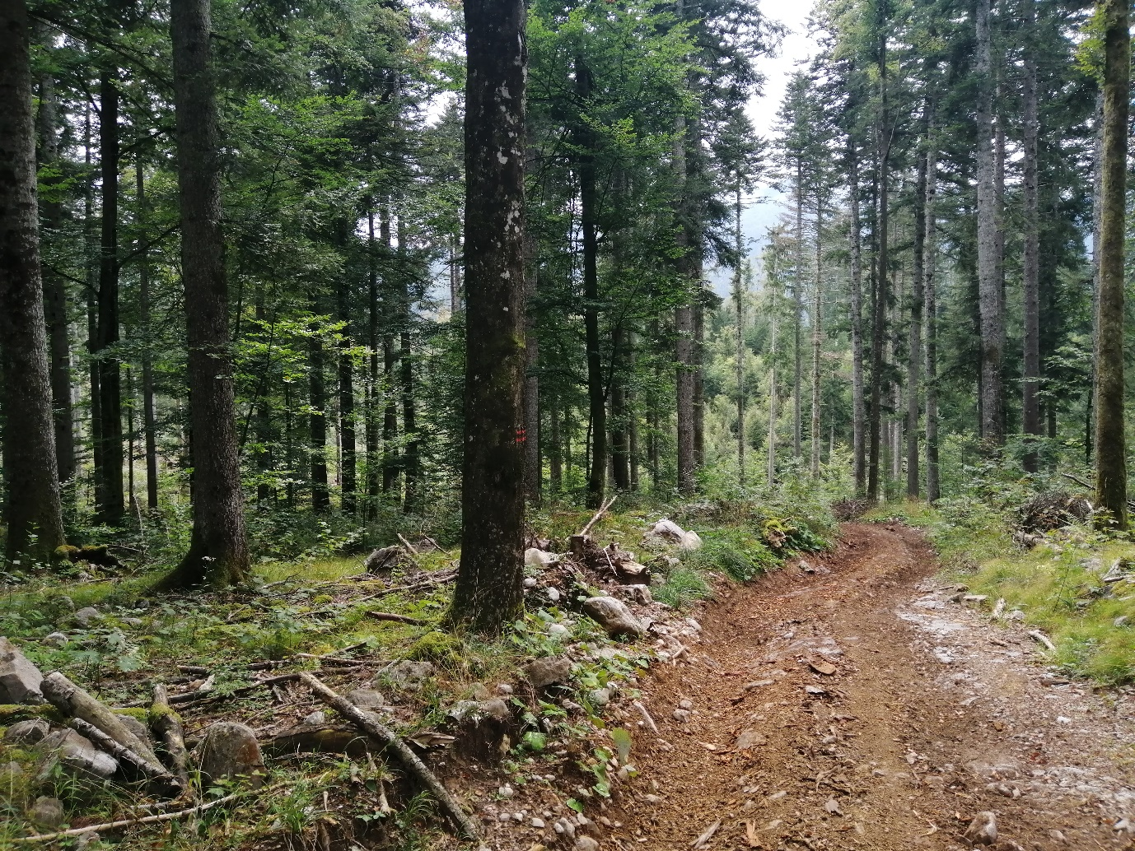
Slika 1: Gozd (foto: A Alagić)
Fig 1: Forest (photo: A. Alagić)
or
Slika 1: Gozd (vir: [navedba vira po načelu avtor-leto in navedba vira v seznamu uporabljenih virov]
Fig 1:: Forest (source: [citation of the source according to the author-year principle and complete bibliographical information in the chapter references])

4 DISCUSSION AND CONCLUSIONS

4 RAZPRAVA IN ZAKLJUČKI

5 SUMMARY
5 POVZETEK
Each paper must be equipped with a summary. For manuscripts in Slovenian, the summary shall be in English and shall not exceed 3,800 characters, while for manuscripts in English or another IUFRO language, an extended (up to 7,000 characters) summary in the Slovenian language must be provided. In case of problems with ensuring translation to Slovenian, please contact the editorial office.
ACKNOWLEDGEMENTS
ZAHVALA

REFERENCES

VIRI
All references must be cited in the text and listed in alphabetical order in the list of references.

In-text citations should follow the principle (Author, year), in the case of two authors (Author and Author, Year), multiple authors (Author et al., year) or (Title, year). Group of references should be listed chronologically, older references first, e.g. (Novak, 2008; Kappes and Petterson, 2009; Novak et al., 2010, Pregledovalnik … s. a.).

If the year of the source is unknown (especially in the case of online sources), the term s. a. should be used (sine anno, no year).

Use of references by the same author or the same group of authors, published in the same year, should be separated with the use of a letter mark after the year of publication, e.g. (Diaci et al., 2022a, 2022b) and the same in the reference list.

The use of multiple references of authors with the same last name and the same year should be distinguished by the added initials of the names, e.g. (Jurc D., 2000, Jurc M., 2000, Jurc, 2001).

All references cited in the text, tables and figures should be listed in alphabetical order in the list of references, arranged alphabetically by the last name of the first author (or the first two, or the title) and chronologically.

In bibliographic description the prescribed order of elements, separators between them and other peculiarities should be used.
- The initials of the names should be listed as follows (no space between initials): Nagel T.A. (not Nagel TA, or Nagel T. A.).
- Initials of resource titles should be written according with the rules of the language of the source.
- English titles should be written 'as in a sentence', not 'as in a title', e.g. Physiological plant ecology (not: Physiological Plant Ecology).
- Titles of journals should be written with the full name, English titles should be written 'as in the title', e.g. Acta Silvae et Ligni, Forestry Journal, Journal of Applied Ecology.
- Pages should be listed only with articles or chapters, e.g.: 9–19. Pages should be separate with a dash (and not hyphen, which is shorter) and without space between number and dash (a dash is written with the use of ctrl and -).
- Where a DOI exists, it should be listed as an URL-DOI link (https://doi.org/10. …) and without an access date.
- For other references, if the official URL address exists, it should be listed, along with the access date, e.g. (March 7, 2023).
- At the end of the bibliographic description, there should be a consistent final punctuation mark (period).

Terms for articles written in English ed. (editor); (unpublished), (personal source) (email dated).

EndNote style [BF2023.ens] – Checking is recommended before submission. In the case of online sources without a known date of publication, insertion of the term s. a. should be done manually.

Books
Authors. Year. Title. Edition. (Series, no). Place, Publisher. URL-DOI or URL (access date).
Editors (ed.) Year. Title. Edition. (Series, no). Place, Publisher. URL-DOI or URL (access date).
Title. Year. Edition. (Series, no). Place, Publisher. URL-DOI or URL (access date).
Bončina A. (ed.). 2004. Participacija v gozdarskem načrtovanju. (Strokovna in znanstvena dela, 119). Ljubljana, Biotehniška fakulteta.
Mrak T., Gričar J. 2016. Atlas of woody plant roots: morphology and anatomy with special emphasis on fine roots. (Studia Forestalia Slovenica, 147). Ljubljana, Slovenian Forestry Institute, The Silva Slovenica Publishing Centre. https://doi.org/ 10.20315/SFS.147
Book chapter, proceedings papers
Authors. Year. Chapter title. IN: Title of the book/proceedings. Editor (ed.). (Series). Place, Publisher: pages. URL-DOI or URL (access date).
Adamič M. 2004. Participacija pri upravljanju s populacijami prostoživečih živali – možnosti in poskus ocene stanja v Sloveniji. V: Participacija v gozdarskem načrtovanju. Bončina A. (ur.). Ljubljana, Biotehniška fakulteta, Oddelek za gozdarstvo in obnovljive gozdne vire: 59–65. https://repozitorij.uni-lj.si/IzpisGradiva.php?id=126170 (March 6, 2023).

Articles
Authors. Year. Article title. Journal Title, vol., no.: pages. URL-DOI or URL (access date).
Christensen M., Hahn K., Mountford E.P., Ódor P., Standovár T., Roženbergar D., Diaci J., Wijdeven S., Meyer P., Winter S., Vrska T. 2005. Dead wood in European beech (Fagus sylvatica) forest reserves. Forest Ecology and Management, 210, 1–3: 267–282. https://doi.org/10.1016/j.foreco.2005.02.032
Medved M. 1995. Stroški pridobivanja lesa na kmetiji. Gozdarski vestnik, 5, 1: 2–11.
Peteh M., Južnič P. 2016. Značilnosti publiciranja na področju gozdno-lesne verige in njihov vpliv na vrednotenje področij v sklopu evalvacij raziskovalnih dosežkov – pregled objav. Acta Silvae et Ligni, 111: 49–56. DOI 10.20315/ASetL.111.6

Legislation and standards
Law. Year. Journal, numbering. URL (access date).
Standard number: title of the standard. Year. URL (access date).
ISO 11799. Information and documentation: Document storage requirements for archive and library materials. 2003.
Zakon o gozdovih. 1993. Uradni list RS, 30/93. http://pisrs.si/Pis.web/pregledPredpisa?id=ZAKO270 (October 7, 2021).
Online resources
Authors. Year. Website title. URL (access date).
Website title. URL (access date).
Pregledovalnik podatkov o gozdovih. Ljubljana, Zavod za gozdove Slovenije. https://prostor.zgs.gov.si/pregledovalnik (September 4, 2023).
STA, V.Š., K.H. 2019. Italijan za hlod gorskega javorja odštel 15.389 evrov. 24ur.com, February, 13 2019. https://www.24ur.com/novice/gospodarstvo/licitacija-lesa.html (July 5, 2019).

Unpublished sources
Authors. Year. Title, subject. Place, Institution. (unpublished) or (personal source) or (email dated …).
Košir P. 1997. Naravni rezervat Kočevsko. Kočevje, Zavod za gozdove Slovenije (personal source, June 1997).
Werner H. 1995. Bolezni in zajedalci pri kokoših v Prekmurju. V: Simpozij Novi izzivi v poljedelstvu, Radenci, 10.–15. okt. 1995 (unpublished).

